LADDER LOGIC

The Foundational Structure: From Physical Relays to Digital Logic

At its heart, **Ladder Logic** is the main language used to program **PLCs**—those industrial computers that keep machines running like clockwork.

But to really understand it, you’ve gotta know where it came from: the old days of **relay logic** and **hard‑wired control panels**.

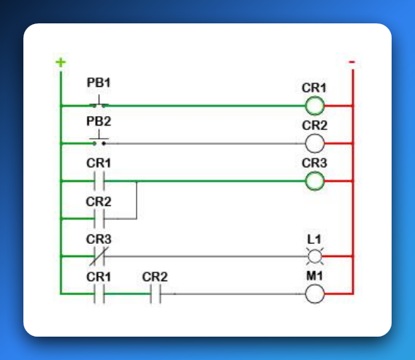

**⚡** 1. The Roots: Relay Logic & Hardware Automation

Before microprocessors were everywhere, factories used **physical relays** to automate machines.

A relay is basically an electrically operated switch:

✅ Send a small current through its coil → it creates a magnetic field → that pulls or releases a metal arm → opening or closing contacts to let power through.

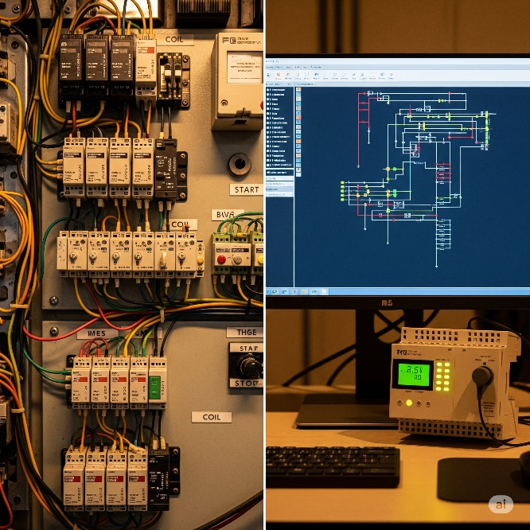

**💥** Why It’s Called a “Ladder”

It’s not just a cute name. Ladder Logic diagrams **look exactly like old relay wiring diagrams**:

Rails (Vertical Lines):

* The **left rail** is the power source (e.g., +24 V DC or 120 V AC).
* The **right rail** is the return path (common/ground).  
  Power always flows left to right.

Rungs (Horizontal Lines):

* Each rung is like one mini‑circuit or one logic rule.
* On each rung, you place components—switches, contacts, coils—in **series** or **parallel**.
* If the path on that rung is complete, the output on the far right energizes.

**⚙️** How It Worked (and Still Does in Principle)

In an old relay cabinet:

* Power starts at the **left rail**, passes through inputs like pushbuttons or sensors, then through relay contacts, and finally reaches an output device like a motor, light, or another relay coil.
* **If every condition on that rung is true (closed contacts, active sensors)** → the circuit completes → the output device gets power and turns on.

Modern Ladder Logic in a PLC mimics this exact same idea—*but instead of physical wires and relays, it’s all done in software.*

**✨** 2. The Evolution: From Tangled Wires to Clean Software Bits

The genius of **Ladder Logic** is how it took the messy world of physical relays and turned it into a neat software language.

Instead of grabbing a screwdriver and wiring real relays together, you **“draw” your logic on-screen** with symbols that look just like the old electrical components.

When the PLC runs your program, it’s basically *pretending* electricity is flowing through those virtual circuits.

**🖥️** Digital Translation – How It Maps Over

Power Flow:  
In software, there’s no real current. Instead, a logical **TRUE (1)** means “power is flowing” along that rung. If the path from the left rail to an output is logically true, that output gets activated.

Open vs. Closed Contacts:  
Physical relay contacts become simple Boolean conditions in the PLC:

* **Normally Open (NO)** – shown as —| |—  
  ✅ True when the input is ON (button pressed, sensor triggered, relay energized).
* **Normally Closed (NC)** – shown as —|/|—  
  ✅ True when the input is OFF (button released, sensor not detecting, relay not energized).

Coils / Outputs:  
Outputs are shown as —( )—.

🚨 When the rung logic leading to that coil is TRUE, the PLC sets that output bit to **1**, which energizes the real-world device (motor spins, light turns on, valve opens) or even an internal memory relay.

👉 Big Picture:  
Instead of digging through wires in a control cabinet, you’re now dragging and dropping logic in software.

**Same principles, zero mess.** That’s the magic of Ladder Logic.

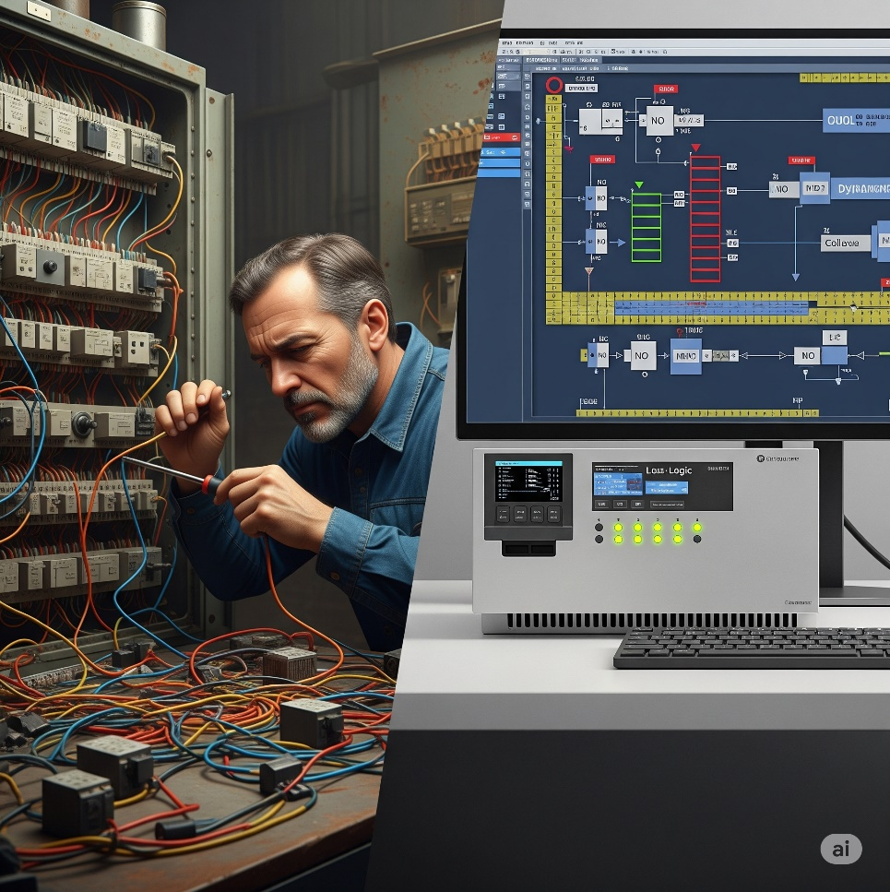

**🏗️** Key Ladder Logic Components & Their Analogies

Let’s break down those classic symbols from your image and see how they vibe both in hardware *and* in software logic:

**🔘** PB (Pushbutton) – Your Event Trigger

**PB1, PB2:** These are **inputs**.  
On a real panel, pressing a pushbutton closes a circuit and sends a signal into a PLC input terminal.  
In Ladder Logic, it’s represented by a contact symbol.

**👉 Analogy:**  
A pushbutton is like calling a function or triggering an interrupt in code.  
When you hit it, you’re saying: *“Yo, start that sequence!”*

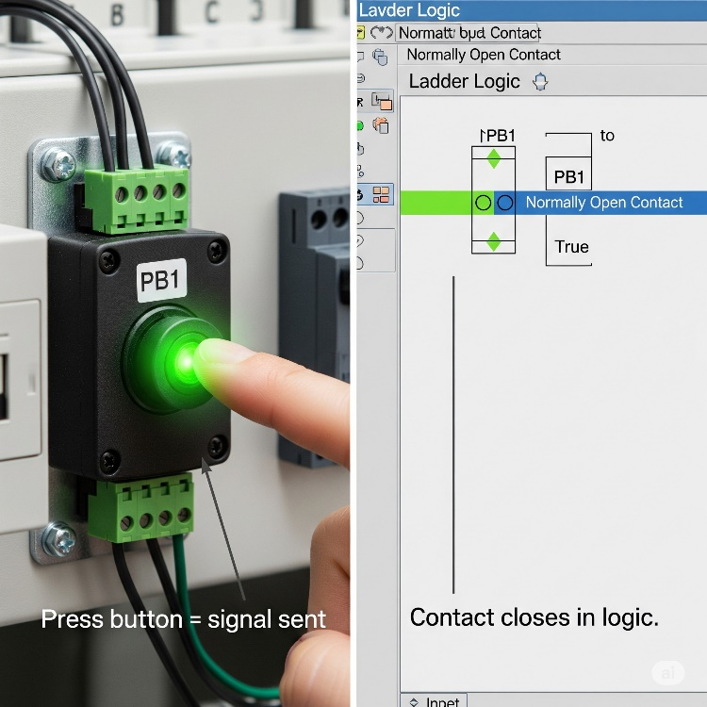

**⚡** CR (Control Relay) – Your Internal State & Your Electrical Middle‑Man

**CR1, CR2, CR3:**  
Inside Ladder Logic, we treat these as **internal memory bits** — energize the coil (CR1) and every CR1 contact in your logic instantly follows that state.

**But in the real hardware world?**  
A control relay also acts as an **electrically controlled switch**.  
It lets the PLC — which only pushes tiny, low‑power signals — safely control **higher‑power devices** like motors, solenoids, or large lamps.  
It’s the buffer between the fragile logic electronics and the beefy machinery, giving you:  
✅ **Electrical isolation** (protects your PLC from power spikes),  
✅ **Safety** (no direct heavy current through your delicate PLC board),  
✅ **Stability** (reliable switching for big loads).

**👉 Analogy:**  
Think of it as a bouncer at a club.  
Your PLC quietly whispers, “let them in,” and the control relay (the bouncer) swings open the big heavy door to the motor or solenoid.  
The PLC never has to wrestle with high current directly — the relay does the heavy lifting.

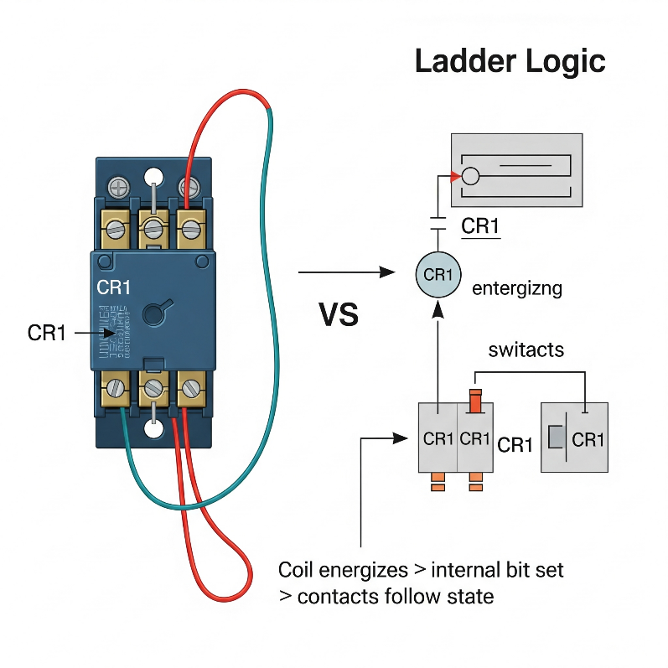

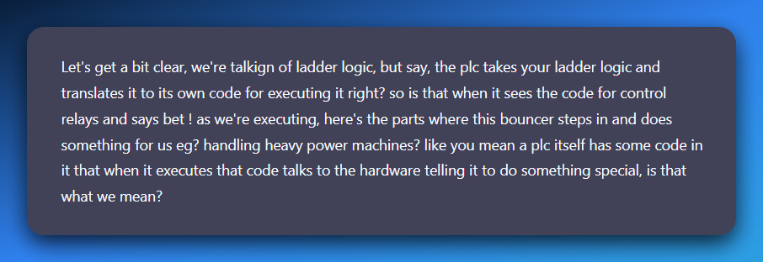

Inside your ladder, when you drop in a coil (CR1) or an output (M1) you’re basically saying to the PLC:

*“Hey PLC, if the logic on this rung is true, energize this output (or set this internal bit).”*

**What happens next depends on what type of coil it is:**

**💥** Internal CR (Control Relay):

* This one lives purely in PLC memory.
* When the CPU executes that rung and it’s true, it sets a *bit* in memory to 1.
* Any rung reading that contact (—| |— CR1) will now see it as “closed.”  
  👉 No actual electricity is switching heavy loads yet — it’s just logic inside the PLC.

**💥** Physical Output Coil (like M1 for a motor):

* When the CPU executes that rung and it’s true, it flips a transistor or energizes a tiny driver circuit on the PLC’s output card.
* That tiny driver is *not* strong enough to power a motor directly — and that’s where real **control relays** or **contactors** out in the panel come in.
* The PLC output energizes the relay coil (low current).
* The relay’s contacts then safely switch the **big current** going to your motor or solenoid.

The PLC scan loop runs through your compiled logic thousands of times a second. Each time it hits an output coil instruction, the CPU updates the hardware output register.

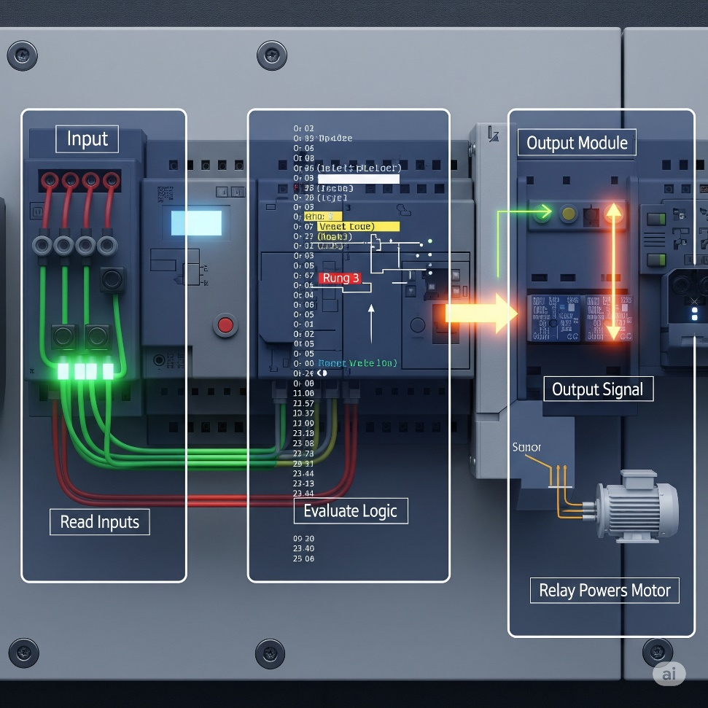

**That register is connected to output modules** — which physically drive relay coils, solid‑state switches, or transistors on your control panel.

The **PLC isn’t** literally muscling 10 amps into a motor — it’s *flipping a small digital signal* that *commands* the relay/contactors to handle the big current.

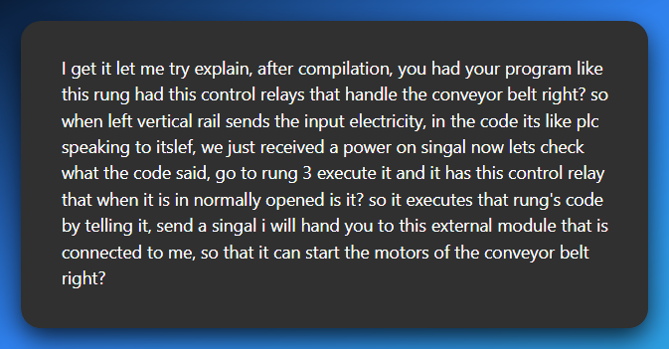

After your ladder logic is compiled, the PLC is constantly scanning. Imagine we’re mid‑scan:

⚡ Input side:  
The PLC reads the status of all input terminals (pushbuttons, sensors, etc.).  
👉 The left rail is like “power” coming in, but in PLC land it’s really just reading TRUE/FALSE from each input.

🧠 Logic side:  
Now the PLC runs through your ladder rungs, top to bottom: *“Ok, rung 3… oh, this rung has a coil that controls the conveyor motor. Let’s check the contacts in this rung.”*

It evaluates your contacts (normally open/closed) based on the input states and internal bits. If the logic path is TRUE (like that normally open contact is now closed because the button was pressed): *“Alright, condition is true — energize that output coil!”*

📤 Output side:  
The PLC doesn’t directly blast **3-phase power(typically provides higher electrical power)**. Instead, it sends a low‑power signal out of an output pin on the output module:

*“Hey output module, set your transistor/relay ON for Conveyor_Motor.”*

🔌 External world:  
The output module energizes a control relay or contactor coil out in the panel.  
**That relay/contact closes heavy-duty contacts that feed the actual conveyor motor’s power circuit.** 👉 And boom — your conveyor motor spins up. 🚀

**🤖** So your sentence becomes:

*“When the PLC is scanning and gets to rung 3, it evaluates that rung’s logic (including your control relay contact). If the logic is TRUE, the PLC sends a signal from its output module to energize an external relay or contactor, which then powers the conveyor motor.”*

Your idea is absolutely right.  
✅ Left rail = inputs read.  
✅ Code rung-by-rung.  
✅ If logic says “go,” PLC outputs a low‑power signal.  
✅ Output module reads the signal → control relay/contact closes → heavy machine (like the conveyor starts moving).

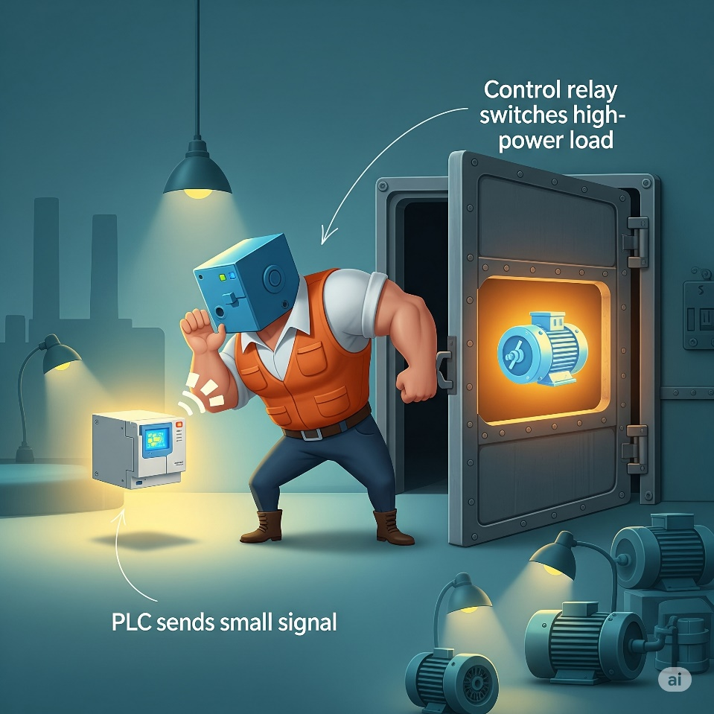

We talked about **(CR1)** as a "coil" and (L1) or (M1) as "output devices." These are essentially the "coils" that get energized.

When a rung's conditions are met, the "output coil" on that rung gets "energized." If it's an internal CR (Control Relay), it sets a memory bit.

If it's a physical output like L1 or M1, it triggers the corresponding output module on the PLC to provide power to the actual device.

**⚡** The Evolution from Wires to Code – Ladder Logic’s Secret Sauce

*Ladder Logic* didn’t just give old relay panels a digital facelift — it *fundamentally changed* how we think about control systems.

Back in the day, every single relay, switch, and motor in a factory had to be hard‑wired together.

If you wanted to change how it behaved, you grabbed a screwdriver and rewired the whole panel (and probably swore a lot).

Now? Those same circuits *live as memory bits* inside a PLC. Instead of cutting and crimping wires, you “draw” your circuit in software — and the PLC turns that into real‑world action.

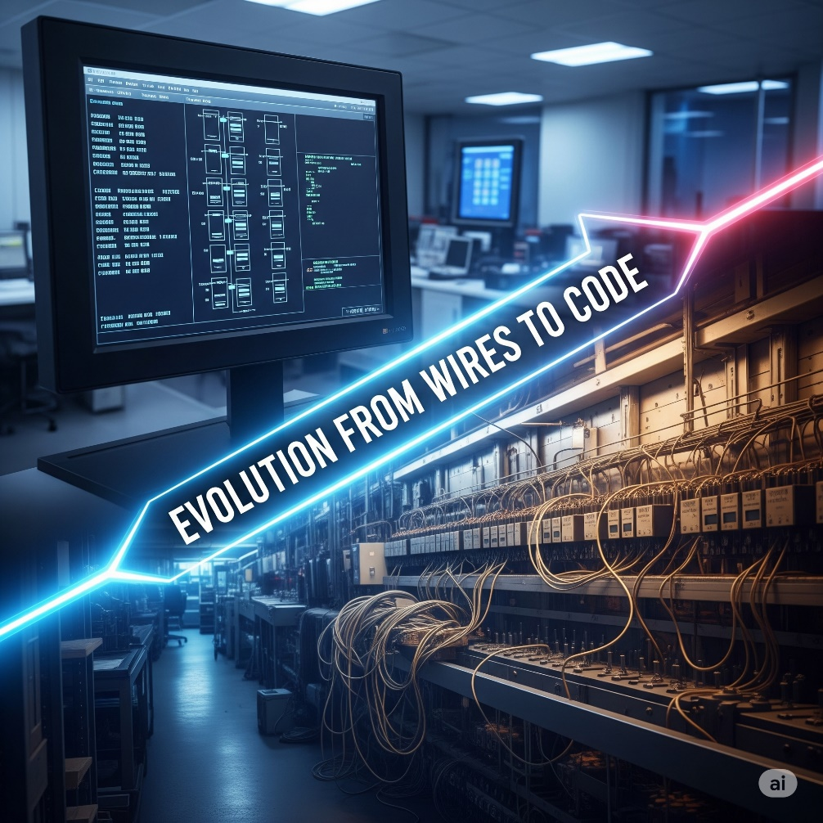

**🛠️** The Ins and Outs: Where Hardware Meets Software

A PLC lives in two worlds at once:

* **Physical world:** pushbuttons, sensors, motors, lights.
* **Digital world:** memory tables, logical rungs, and CPU scans.

The bridge between them? **Input/Output (I/O) modules.**

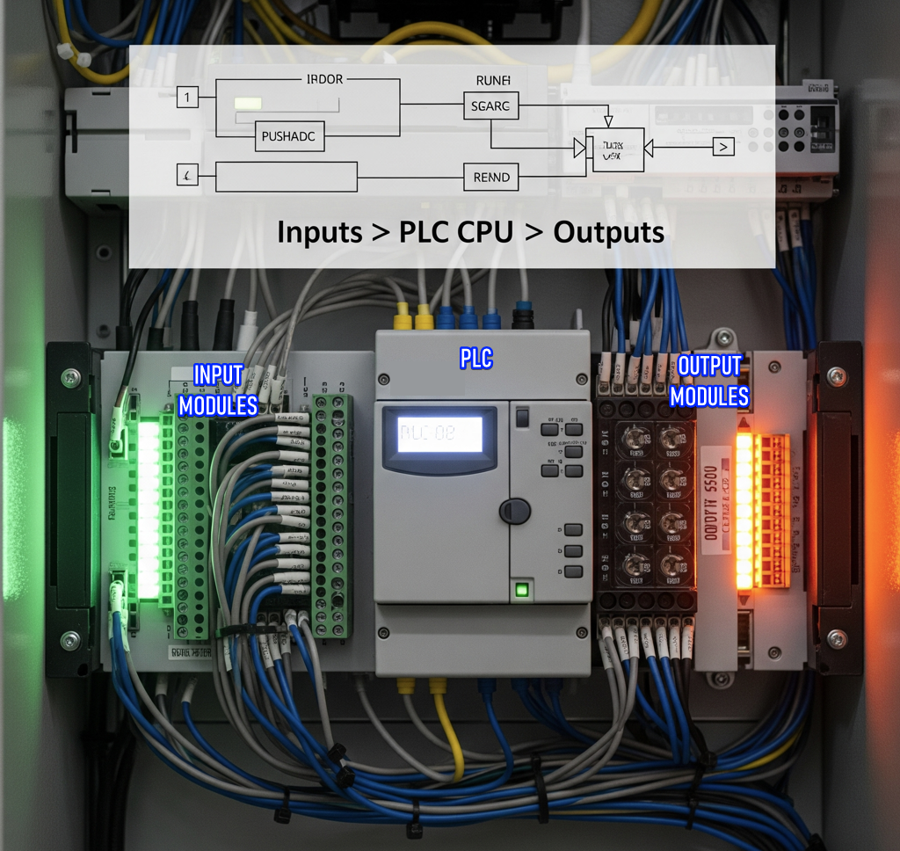

**👁️** Inputs: The PLC’s Eyes and Ears

Inputs are like sensors feeding data into your system.

A pushbutton, a level sensor, or a limit switch sends a voltage into an **input module**. That module samples the signal and says to the CPU:

*“Yo, at address X001, we’ve got power. Mark it as TRUE.”*

Think of it like a network card constantly listening for packets. The input module “listens” for voltage changes on its terminals and updates the PLC’s internal memory bits.

Example:  
🔹 **PB1 wired to X001**

In your ladder, you see —| |— X001. It’s not a literal contact anymore — it’s a *bit check*.

Press PB1 → the input module sets X001 = 1 → that rung’s contact “closes” digitally.

**⚡** Outputs: The PLC’s Muscles

Outputs are the action side. When your ladder logic energizes an output coil, the PLC’s CPU sets a specific output bit, like Y001.

The **output module** takes that bit and physically switches a relay or a transistor that powers your motor, light, or solenoid.

Example:  
🔹 **L1 wired to Y001**  
Your ladder shows —( )— Y001.

Logic on that rung goes TRUE → CPU sets Y001 = 1 → output module energizes the light’s circuit → ✨ L1 turns on.

Analogy time:  
➡ Inputs are like status packets coming in.  
➡ Outputs are like commands going out.  
The CPU is the router/firewall/brain in between, deciding when to flip those outputs based on the logic you programmed.

**🔒** Why This Shift Matters

* **Old days:** Change in behavior? Rewire the panel. Hours of work. Tons of errors.
* **Now:** Change in behavior? Edit your ladder program, download it, and you’re done.
* Physical contacts and coils → now abstracted as memory bits (X, Y, M, etc.) in the PLC’s brain.

**💡** TLDR:  
Ladder Logic isn’t just “drawing circuits on a screen.” It’s a translation layer:  
✅ Physical inputs become digital bits (via input modules).  
✅ Logic rungs operate on those bits.  
✅ Outputs become real‑world actions (via output modules).

And yeah — when you tell a rung to energize a control relay that drives a conveyor belt, the PLC *literally flips that memory bit* and the hardware module says:

*“Bet! Let’s send some juice to that motor.”*

💻 2. Internal Logic: The Hidden Power of Memory Bits

Inside a PLC, not every decision ties directly to a physical wire. Some of the most important signals live entirely in software as **internal memory bits**—tiny flags in the PLC’s brain that let you build smarter, more modular logic without ever touching an output terminal.

**🧠** Control Relays (CRs): Your Virtual Switches

These are the MVPs of internal bits. A control relay in Ladder Logic doesn’t physically click like a hardware relay—it’s a *state variable* inside the PLC.

* One rung can **set** it to TRUE.
* Dozens of other rungs can **check** that state later as if it were an input.

**Analogy:**  
Think of CRs like global bool variables in a C program:

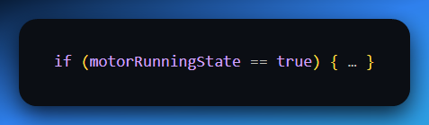

or like flags in malware indicating stages of execution (isEscalated, persistenceSet). They’re pure logic—no wires attached—yet they control the flow of everything else.

**✨** Temporary Storage and Modular Thinking

Internal bits aren’t just for persistent states. They’re your scratchpads for holding intermediate results.

Want to simplify a big tangled rung? Break it up into smaller rungs and store partial results in internal bits. Your future self (and your debugging process) will thank you.

**🚀** Beyond Contacts and Coils: Modern PLC Superpowers

Classic relay panels could only dream of what a modern PLC CPU can do with these internal bits as building blocks. Once you master CRs, you unlock access to a full toolbox of advanced functions:

✅ **Math Functions:** Add, subtract, multiply, divide—use them to control temperatures, pressures, or calculate throughput on the fly.

✅ **Shift Registers:** Track items moving along a conveyor with perfect sequence.

✅ **Drum Sequencers:** Automate complex multi-step tasks (batch processing, assembly sequences) like a virtual music drum triggering events.

✅ **PID Control:** Keep variables like temperature or speed rock‑steady with closed‑loop feedback—no hand‑tuning every scan.

✅ **Data Handling:** Move, compare, or manipulate large chunks of data inside the PLC.

✅ **Communication Protocols:** Talk directly to other PLCs, HMIs, SCADA systems, or even ERP databases using Ethernet/IP, Modbus TCP, Profinet—you name it.

✅ **Alternative Languages:** Want something beyond Ladder? Many PLCs support **Structured Text (ST)**, **Function Block Diagrams (FBD)**, and **Sequential Function Charts (SFC)**, letting you mix high‑level logic with your ladder for maximum flexibility.

💡 Bottom line:  
Internal memory bits are your secret weapons. They let you build layered, scalable logic inside the PLC without extra hardware. Combine them with modern CPU features and your humble ladder program evolves into an *industrial‑grade control system*.